
Faculty of Science

Course: CSCI 2020u – Software System Development & Integration
Component: Assignment
Weight: 10%
Deadline: March 5, 2020 (due by 11:59pm)

Collaboration Policy
You are permitted to work on this assignment in a team, and submit the results as a team. For this sort of assignment, with an open-ended component, the collaboration between multiple team members can be beneficial. Between groups, however, please limit the discussion to the level of general strategy (not code). Groups of size 2 are recommended. Larger groups will be considered with the proviso that the marker will mark your assignment with higher expectations. In any case, be sure that all members of the team fully understand all code, otherwise they will miss intended learning objectives, which may be a considerable disadvantage at exam time.

How to Submit
You will maintain a git repository for this assignment, which is a public repository. To submit the assignment, create a single file ‘README.txt’ that contains instructions on how to download, compile, and run your codes for each question. A .zip, .7z, or .rar file will not be acceptable. Also submit this word file (once you complete) into related drop box on Blackboard before deadline.

Note: Comments are mandatory. Failure to properly document your program will result in a deduction on the marks you receive for this (and any other) assignment.

Remember:
You need to complete this file and submit it in related drop box on Blackboard, in addition to uploading your codes in your git repository, before deadline.

Group:
Arshad Khan 100695721
Tashdiq Ahmed 100701752
Question 1: Displaying Three Cards

Problem Description:
Display a frame that contains three labels. Each label displays a card, as shown in the figure below. The card image files are named 1.png, 2.png, ..., 54.png and stored in the image/card directory. All three cards are distinct and selected randomly.

The image icons can be found in the attached card folder.

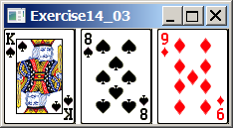
d

Your Task:
- Create three ImageView and set their icons using the images.
- Display three images from 54 image cards randomly.

Your Code:
Copy-paste your code here:

/*
*
* Tashdiq Ahmed 100701752
* Arshad Khan 100695721
*Display a frame that contains three labels.
* Each label displays a card, as shown in the figure below.
* The card image files are named 1.png, 2.png, ..., 54.png
* and stored in the image/card directory. All three cards are
* distinct and selected randomly
*
*
*
*
*
* */
import javafx.application.Application;
import javafx.scene.Scene;
import javafx.scene.image.Image;
import javafx.scene.image.ImageView;
import javafx.stage.Stage;
import javafx.scene.layout.HBox;
import java.util.*;

public class Q1 extends Application {
@Override
public void start(Stage primaryStage) throws Exception {
Random randomGenerator = new Random(); //declearing the random function
int num1 = randomGenerator.nextInt(54) + 1, num2 = randomGenerator.nextInt(54) + 1, num3 = randomGenerator.nextInt(54) + 1; //generating 3 random integers for each card from 1 to 54
int[] card = new int[3]; //for each card
HBox hbox = new HBox(); //declearing the hbox
while(true) { //while loop for getting the random cards
card[0] = num1; //initializing the first card using the random variable
card[1] = num2; //initializing the second card using the random variable
card[2] = num3; //initializing the third card using the random variable
if (card[0]==card[1] || card[1]==card[2] || card[0]==card[2]) { //if there are any of the same cards
num1 = randomGenerator.nextInt(54) + 1; //basically shuffles the deck again
num2 = randomGenerator.nextInt(54) + 1;
num3 = randomGenerator.nextInt(54) + 1;
} else if (card[0]!=card[1] && card[1]!=card[2] && card[0]!=card[2]) break; //only breaks when no random number is the same. This ensures that we get 3 different and random cards
}
for (int i=0;i<card.length;i++) { //this just gets each card image and add it to hbox
hbox.getChildren().add(new ImageView(new Image("image/card/" + String.valueOf(card[i]) + ".png")));
}
Scene scene = new Scene(hbox, 216, 100); //hbox is added to scene

primaryStage.setTitle("Q1 Solution"); //setting the title
primaryStage.setScene(scene); //setting the scene with the hbox
primaryStage.show(); //shows Q1
}
}

Screen shots:
Include two screen shots here:
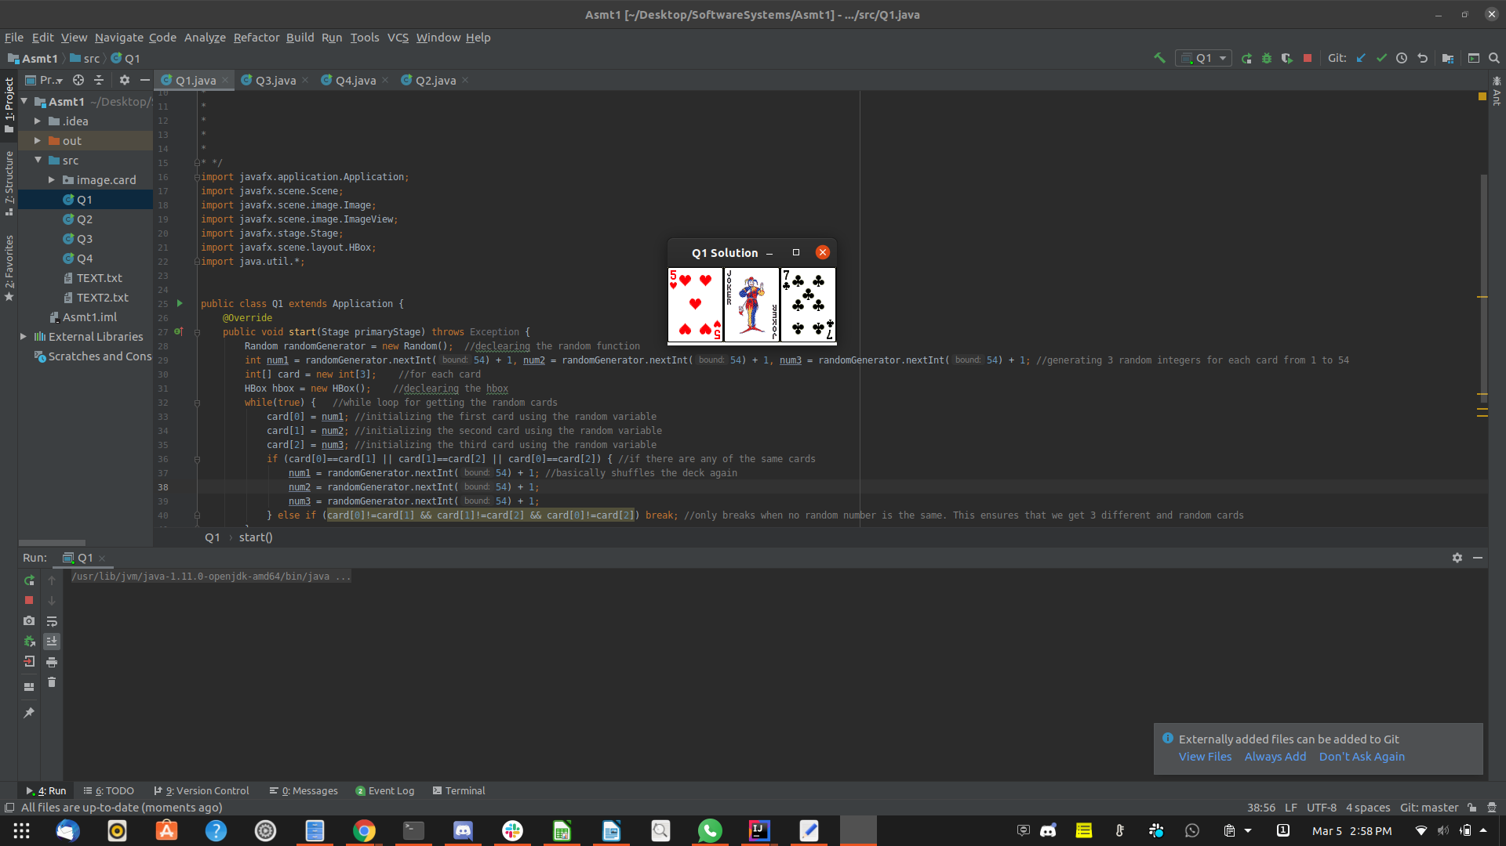

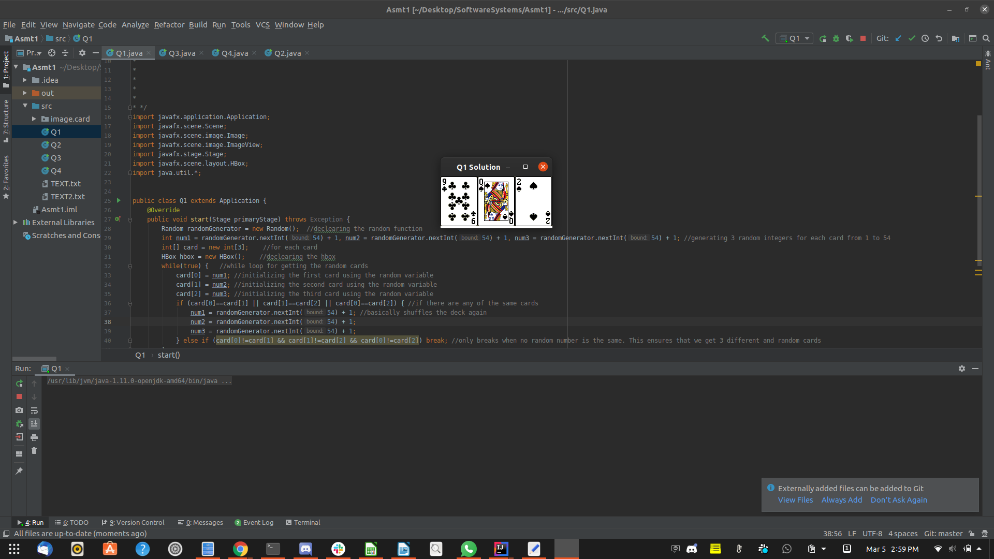

Question 2: Investment-Value calculator

Problem Description:
Write a program that calculates the future value of an investment at a given interest rate for a specified number of years. The formula for the calculation is as follows:

futureValue = investmentAmount * (1 + monthlyInterestRate)years*12

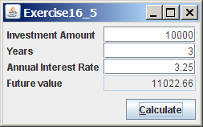

Your Task:
Use text fields for interest rate, investment amount, and years. Display the future amount in a text field when the user clicks the Calculate button, as shown in the figure.

Your Code:
Copy-paste your code here.

/*
* Tashdiq Ahmed 100701752
* Arshad Khan 100695721
* Problem Description:
* Write a program that calculates the future value of an investment at
* a given interest rate for a specified number of years.
* The formula for the calculation is as follows:
* futureValue = investmentAmount * (1 + monthlyInterestRate)years*12
*
*
*
*
*
* */
import javafx.application.Application;
import javafx.geometry.Insets;
import javafx.geometry.Pos;
import javafx.scene.Scene;
import javafx.scene.control.*;
import javafx.scene.text.Text;
import javafx.scene.layout.GridPane;
import javafx.stage.Stage;
import java.lang.Math;
import java.text.DecimalFormat;

public class Q2 extends Application {
private static DecimalFormat df = new DecimalFormat("0.00"); //decimal formatting for money (2 decimal places
public void start(Stage primaryStage) throws Exception {
//texts
Text investmentAmount = new Text("Investment Amount"); //text for the Investment Amount

Text years = new Text("Years"); //text for the Years

Text annualInterestRate = new Text("Annual Interest Rate"); //text for the Annual Interest Rate

Text futureValue = new Text("Future Value"); //text for the Future Value

//text field
TextField t1 = new TextField(); //for entering Investment Amount

TextField t2 = new TextField(); //for entering Years

TextField t3 = new TextField(); //for entering Annual Interest Rate

TextField t4 = new TextField(); //for displaying Future Value
t4.setEditable(false); //setting future value textfield so it cannot have stuff entered

//button for the calculate the future value
Button b1 = new Button("Calculate");

//grid pane
GridPane gridpane = new GridPane();

//size for plane
gridpane.setMinSize(400, 220);

//setting padding
gridpane.setPadding(new Insets(10, 10, 10, 10));

//vertical and horizontal gaps between columns
gridpane.setVgap(10);
gridpane.setHgap(10);

//grid alignment
gridpane.setAlignment(Pos.TOP_LEFT);
//arranging everything in grid
//arranging the text and textfield of investmentAmount
gridpane.add(investmentAmount, 0, 0);
gridpane.add(t1, 1, 0);
//arranging the text and textfield of years
gridpane.add(years, 0, 1);
gridpane.add(t2, 1, 1);
//arranging the text and textfield of annualInterestRate
gridpane.add(annualInterestRate, 0, 2);
gridpane.add(t3, 1, 2);
//arranging the text and textfield of futureValue
gridpane.add(futureValue, 0, 3);
gridpane.add(t4, 1, 3);
//arranging for the calculate button
gridpane.add(b1, 1, 4);
//lambda function for when the user presses the "calculate" button
b1.setOnAction(e-> {
double eIA = Double.parseDouble(t1.getText()); //parsing the test from the first textfield to a double
double eY = Double.parseDouble(t2.getText()); //parsing the test from the second textfield to a double
double eAIR = Double.parseDouble(t3.getText()); //parsing the test from the third textfield to a double
double eFV = (double) (eIA*Math.pow((1+(eAIR/1200)),(eY*12))); //calculating the future value
String result = df.format(eFV); //formatting the string result of the future value
// String result = String.valueOf(eFV);
t4.setText(result); //setting the text to display the calculated future value
});
Scene scene = new Scene(gridpane); //adding gridplane to the scene

//title
primaryStage.setTitle("Q2 Solution");

//adding scene to the primaryStage
primaryStage.setScene(scene);

//displaying contents
primaryStage.show();
}
}

Screen shots:
Include two screen shots here:

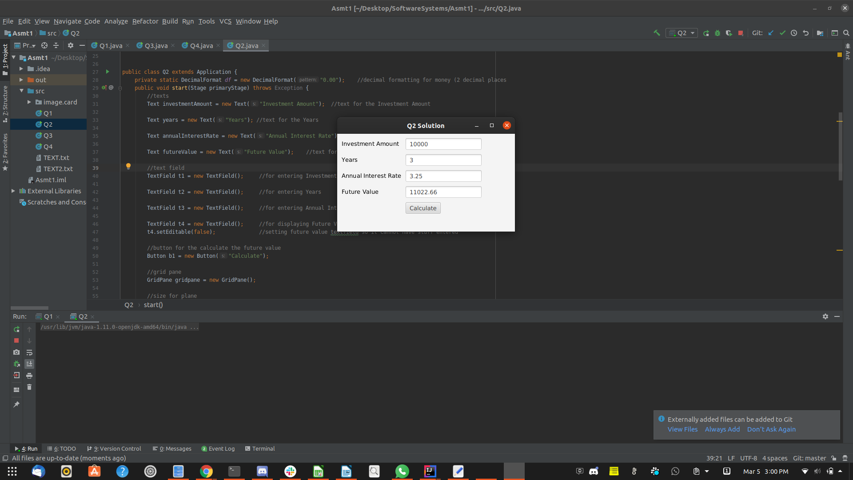
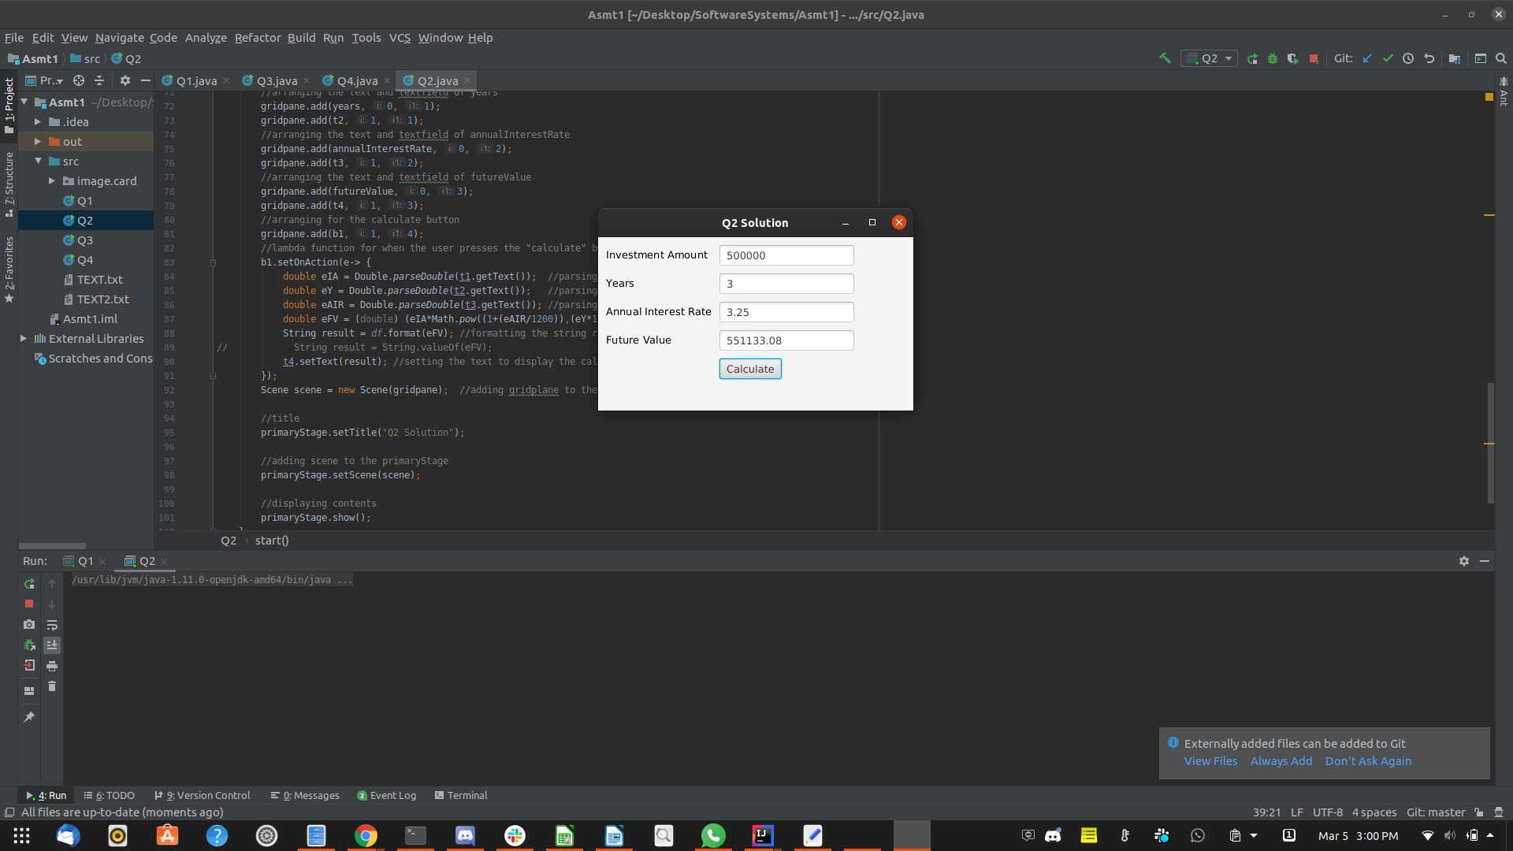
Question 3: Dragging Points on a Circle

Problem Description:
Draw a circle with three random points on the circle. Connect the points to form a triangle. Display the angles in the triangle. Use the mouse to drag a point along the perimeter of the circle. As you drag it, the triangle and angles are redisplayed dynamically.

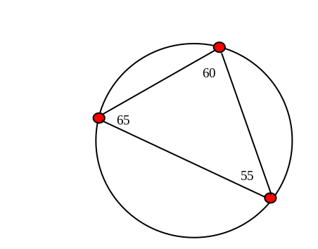

Here is the formula to compute angles:

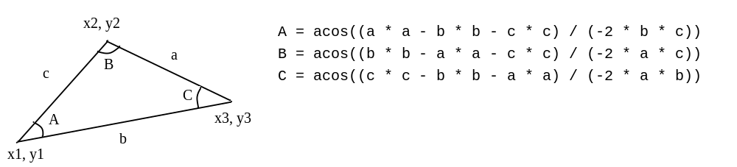

Your Code:
Copy-paste your code here:

/*
* Tashdiq Ahmed 100701752
* Arshad Khan 100695721
* Problem Description:
* Problem Description:
* Draw a circle with three random points on the circle.
* Connect the points to form a triangle. Display the angles
* in the triangle. Use the mouse to drag a point along the perimeter
* of the circle. As you drag it, the triangle and angles are redisplayed
* dynamically.
*
*
*
*
*
* */
import javafx.application.Application;
import javafx.scene.Group;
import javafx.scene.Scene;
import javafx.scene.layout.Pane;
import javafx.scene.shape.Line;
import javafx.stage.Stage;
import javafx.scene.shape.Circle;
import javafx.scene.paint.Color;
import javafx.geometry.Point2D;
import javafx.scene.text.Text;

import java.util.Random;

import static java.lang.Math.*;

public class Q3 extends Application {
Group root = new Group();
Circle MainCircle = new Circle(); //this is the main circle that the three points have to osscatite around
Circle[] points = {new Circle(), new Circle(), new Circle()}; //these are the three different points, they are just much smaller circles (circle array)
Line[] lines = {new Line(points[0].getCenterX(),points[0].getCenterY(),points[1].getCenterX(),points[1].getCenterY()), //this creates the 3 different lines for connecting the points (line array)
new Line(points[1].getCenterX(),points[1].getCenterY(),points[2].getCenterX(),points[2].getCenterY()),
new Line(points[2].getCenterX(),points[2].getCenterY(),points[0].getCenterX(),points[0].getCenterY())
};
double[] angles = getAngles(); //initializing the angles
Text[] anglesTxt = {new Text(points[0].getCenterX(),points[0].getCenterY()-15,String.format("%.1f", toDegrees(angles[0]))), //just creating the texts for the angles to be displayed
new Text(points[1].getCenterX(),points[1].getCenterY()-15,String.format("%.1f", toDegrees(angles[1]))),
new Text(points[2].getCenterX(),points[2].getCenterY()-15,String.format("%.1f", toDegrees(angles[2])))
};
public void start(Stage primaryStage) throws Exception {
MainCircle.setCenterX(300.0f); //conditions for the main circle that the point for making the triangle go around
MainCircle.setCenterY(300.0f);
MainCircle.setRadius(100.0f);
MainCircle.setFill(Color.TRANSPARENT);
MainCircle.setStroke(Color.BLACK);
MainCircle.setStrokeWidth(1.5);

displayRandomPoints(MainCircle, points); //this generates the random position for the points (circle "points" array)

Pane pane = new Pane();

root.getChildren().add(MainCircle); //just adds it to the Group for displaying

for (int i = 0; i < points.length; i++) {
points[i].setFill(Color.RED); //just making the fill color red like in the doc
points[i].setStroke(Color.BLACK); //and the border of the points black
final int index=i;
points[i].setOnMouseDragged((e) -> { //lambda function for setting the mouse dragging of the points
Point2D Center = new Point2D(MainCircle.getCenterX(), MainCircle.getCenterY()); //gets the center of the main circle
Point2D mouse = new Point2D(e.getX(), e.getY()); //gets x and y position of the mouse
Point2D centerToMouse = mouse.subtract(Center); //getting the different between the mouse and the center of the circle
Point2D centerToNewPoint = centerToMouse.normalize().multiply(MainCircle.getRadius()); //helps to get the points position to be limited to the circle
Point2D newPoint = centerToNewPoint.add(Center); //creating that new point
points[index].setCenterX(newPoint.getX()); //sets it to the circle "points" array position in x
points[index].setCenterY(newPoint.getY()); //sets it to the circle "points" array position in y
// System.out.println("(x = " + newPoint.getX() + " , y = " + newPoint.getY() + ")");
update(lines, points); //calls the update which helps to update the lines for a new "point" and it also helps to get the angles
// getAngles();
anglesTxt[index].setX(points[index].getCenterX()); //this just sets the position of the angle text for the x position
anglesTxt[index].setY(points[index].getCenterY()-15); //this just sets the position of the angle text for the y position
});
pane.getChildren().add(points[i]); //adds the points to the Pane
}
update(lines, points); //calls the update to add the lines to the pane as well as the angle texts
pane.getChildren().addAll(lines);
pane.getChildren().addAll(anglesTxt);
root.getChildren().add(pane); //adds the pane to the group for displaying
//Creating a scene object
Scene scene = new Scene(root, 600, 600);
//Setting title to the Stage
primaryStage.setTitle("Q3 Solution");
primaryStage.centerOnScreen();
//Adding scene to the stage
primaryStage.setScene(scene);

//Displaying the contents of the stage
primaryStage.setResizable(false); //so you cant resize the window to mess up the centering
primaryStage.show();
}

private double[] getAngles() { //just returns the angles array
double a = hypot(points[1].getCenterX()-points[2].getCenterX(),points[1].getCenterY()-points[2].getCenterY()); //calculates the hypotneus for each line
double b = hypot(points[0].getCenterX()-points[2].getCenterX(),points[0].getCenterY()-points[2].getCenterY());
double c = hypot(points[1].getCenterX()-points[0].getCenterX(),points[1].getCenterY()-points[0].getCenterY());

double[] angle = new double[3];
angle[0] = acos((a*a -b*b - c*c)/(-2*b*c)); //calculates the angles
angle[1] = acos((b*b -a*a - c*c)/(-2*a*c));
angle[2] = acos((c*c -b*b - a*a)/(-2*b*a));
return angle;
}
private void displayRandomPoints(Circle mainCircle, Circle[] points) { //this generates random points for the circle "points" array
double angle, xPos, yPos;
for (int i=0;i<points.length;i++) {
angle = (random() * 360); //gets a random val from 0 to 360
xPos = mainCircle.getRadius()*cos(angle)+300; //calculates the x position with the given angle, the 300 is there to help center the x position on the main circles border
yPos = mainCircle.getRadius()*sin(angle)+300; //calculates the y position with the given angle, the 300 is there to help center the y position on the main circles border
points[i].setCenterX(xPos); //setting the x position of the "points"
points[i].setCenterY(yPos); //setting the y position of the "points"
points[i].setRadius(7.0f); //setting size of the circle "points" array
}
}
//the update just updates the lines and angles
private void update(Line[] lines, Circle[] points) {
int pointsIndex;
for (int i=0;i<points.length;i++) { //just initializes the start and end points of the line in x and y position when the update method is called
if (i+1>=points.length) {
pointsIndex = 0;
} else {
pointsIndex = i+1;
}
lines[i].setStartX(points[i].getCenterX());
lines[i].setStartY(points[i].getCenterY());
lines[i].setEndX(points[pointsIndex].getCenterX());
lines[i].setEndY(points[pointsIndex].getCenterY());
}
getAngles(); //gets the angles, then makes sure to reset the angles when the update is called
double a = hypot(points[1].getCenterX()-points[2].getCenterX(),points[1].getCenterY()-points[2].getCenterY());
double b = hypot(points[0].getCenterX()-points[2].getCenterX(),points[0].getCenterY()-points[2].getCenterY());
double c = hypot(points[1].getCenterX()-points[0].getCenterX(),points[1].getCenterY()-points[0].getCenterY());

angles[0] = acos((a*a -b*b - c*c)/(-2*b*c));
angles[1] = acos((b*b -a*a - c*c)/(-2*a*c));
angles[2] = acos((c*c -b*b - a*a)/(-2*b*a));
for (int j=0;j<3;j++) { //sets the angles using the text
anglesTxt[j].setText(String.format("%.1f", toDegrees(angles[j]))); //format is 1 decimal place
anglesTxt[j].setX(points[j].getCenterX()); //sets the texts x position for each "point"
anglesTxt[j].setY(points[j].getCenterY()-15); //sets the texts y position for each "point"
}

}
}

Screen shots:
Include two screen shots here:

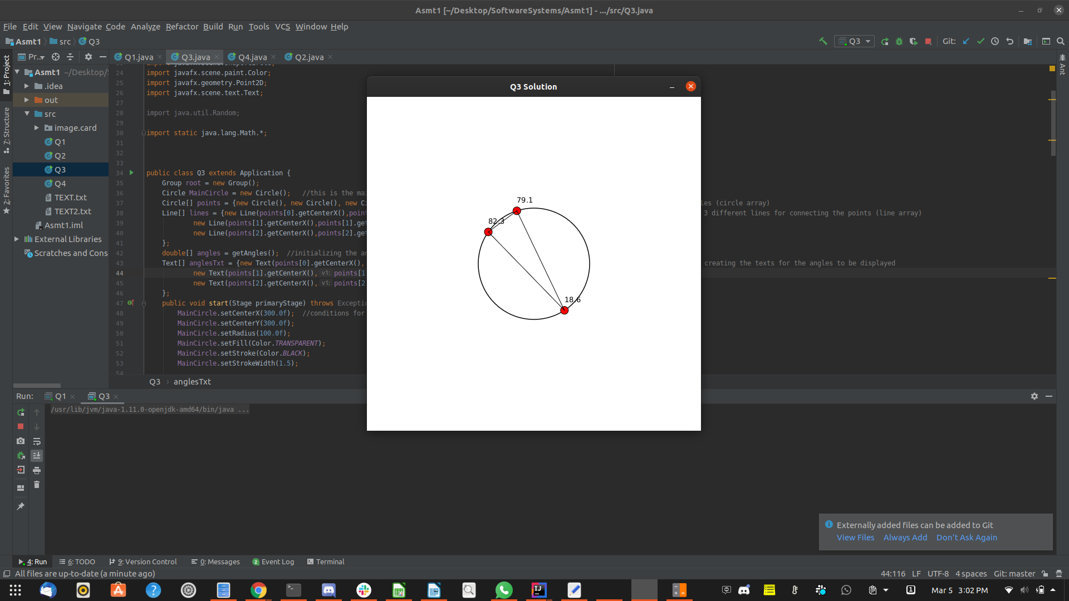
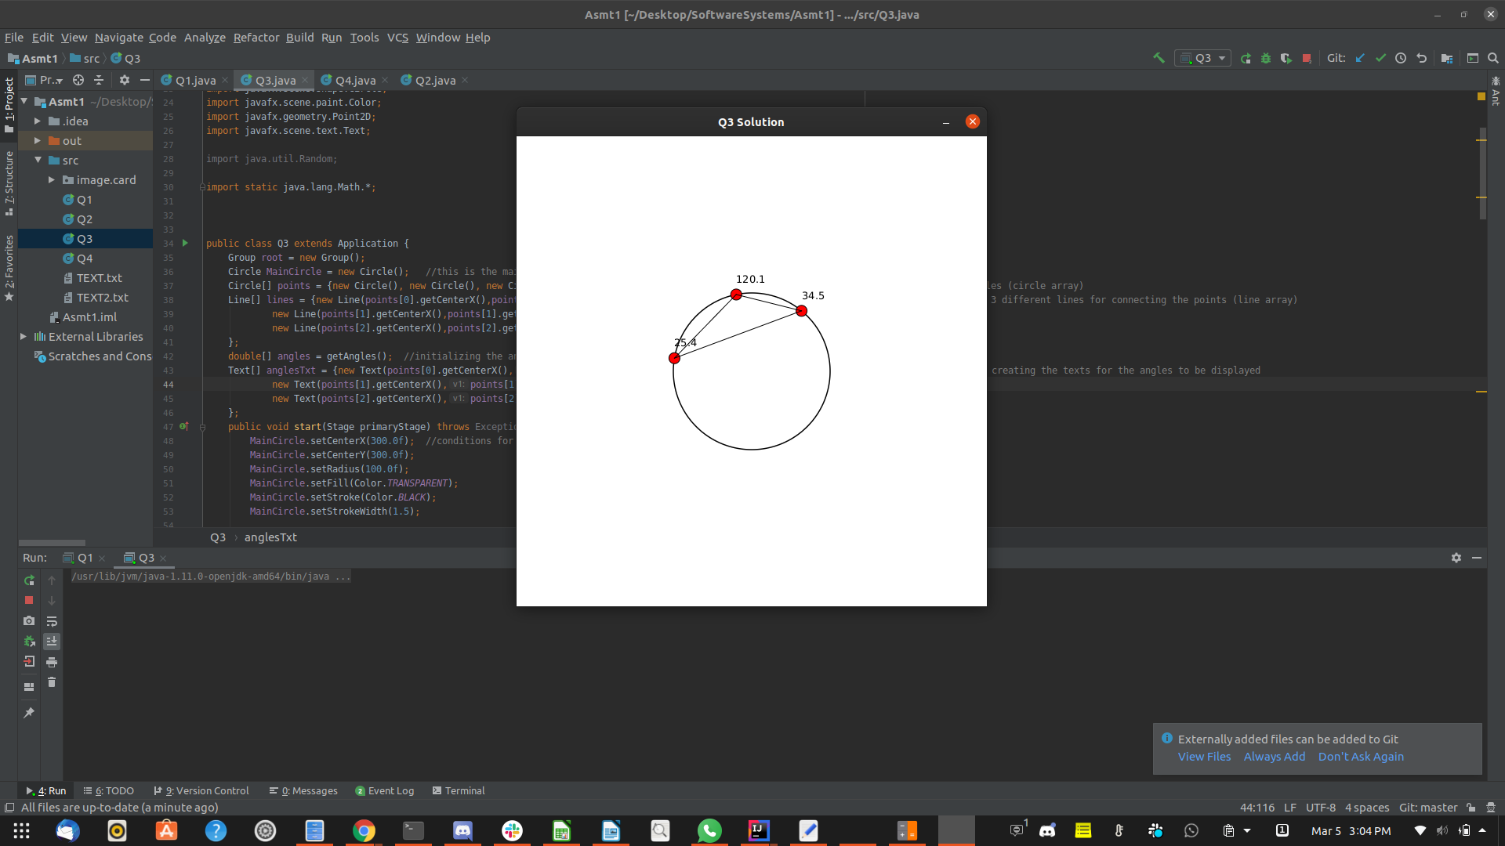

Question 4: Histogram

Problem Description:
Develop a program that displays a histogram to show the occurrences of each letter in a text area. The histogram should show the occurrences of each letter in a text file, as shown in the following figure. Assume that the letters are not case sensitive.

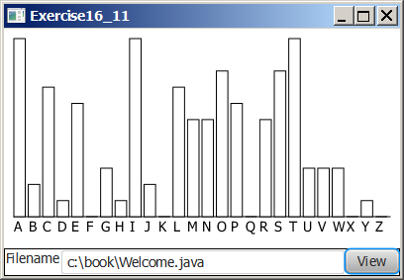

Your Task:
- Place a pane that will display the histogram in the center of the frame.
- Place a label and a text field in a panel, and put the panel in the south side of the frame. The text file will be entered from this text field.
- Pressing the Enter key on the text field causes the program to count the occurrences of each letter and display the count in a histogram.

Your Code:
Copy-paste your code here:

/*
* Tashdiq Ahmed 100701752
* Arshad Khan 100695721
* Problem Description: Develop a program that displays a histogram to show the
* occurrences of each letter in a text area. The histogram should show the occurrences
* of each letter in a text file, as shown in the following figure.
* Assume that the letters are not case sensitive.
*
*
*
*
* */
import javafx.application.Application;
import javafx.scene.Scene;
import javafx.scene.chart.BarChart;
import javafx.scene.chart.CategoryAxis;
import javafx.scene.chart.NumberAxis;
import javafx.scene.chart.XYChart;
import javafx.scene.input.KeyCode;
import javafx.scene.layout.BorderPane;
import javafx.stage.Stage;
import java.io.BufferedReader;
import java.io.File;
import java.io.FileReader;
import java.io.IOException;
import javafx.scene.control.*;
import javafx.scene.layout.Pane;

public class Q4 extends Application {
final static String alphabet[] = {"A", "B", "C", "D", "E", "F", "G", "H", "I", "J", "K", "L", "M", "N", "O", "P",
"Q", "R", "S", "T", "U", "V", "W", "X", "Y", "Z"}; /*Array to keep track of all
the categories on the X axis. Also used for a convenient loop later to add data to the chart.*/
private static String filename=""; //A string to hold the name of the file to-be. Used to check if it exists.
private static int[] freqs = new int[26]; //Int array to hold the amount of times each letter appears.
public int[] countLetters(String TEXT) throws IOException{ /*Function to count the amount of letters in the file.
Takes the name of the file as a parameter.*/
BufferedReader in = new BufferedReader(new FileReader(TEXT)); //Input stream.
String line;
while((line = in.readLine()) != null){ //As long as there is a line to read...
line = line.toUpperCase(); //Case doesn't matter, so we can force everything to upper case for convenience
for(char ch:line.toCharArray()){
if(Character.isLetter(ch)){
freqs[ch - 'A']++;
/*Function loops for each letter in the array/former line. Increments the counter of whatever letter
in the alphabet array that it's currently on.*/
}
}
}
in.close(); //Closing the input stream.
return freqs;
}

public void start(Stage stage) throws Exception {
TextField t1 = new TextField(); //Creating the text field for the user-input filepath
t1.setPromptText("Filename");
BorderPane borderpane = new BorderPane(); //Borderpane for later use
stage.setTitle("Q4 Solution");
final CategoryAxis xAxis = new CategoryAxis(); //Creating axises for the chart
final NumberAxis yAxis = new NumberAxis();
final BarChart<String,Number> chart = new BarChart<String,Number>(xAxis,yAxis); //Creating the empty chart
chart.setCategoryGap(0);
chart.setTitle("Letter Frequency");
xAxis.setLabel("Letters");
yAxis.setLabel("Frequency");
XYChart.Series series1 = new XYChart.Series(); //Empty set of data to eventually put in the chart
// series1.setName("Frequency");
t1.setOnKeyPressed(e-> { //Key press event
chart.getData().clear();
if (e.getCode() == KeyCode.ENTER) //If the key is enter
{
File inputFile = new File(t1.getText());
if (!inputFile.exists()) {
System.out.println("File not found. Is the path correct?");
return; //If the file is not found, the code is "cancelled"
}
else {
System.out.println("File found. Creating chart.");
}
try {
for (int i=0; i<26; i++) {
freqs[i] = 0;/*Sets the frequency values to 0 whenever the enter key is pressed, since each
enter press is assumedly a new text file to chart*/
}
countLetters(t1.getText()); //Function call to count the letters
for (int x=0; x<alphabet.length; x++) {
XYChart.Data<String, Number> data1 = new XYChart.Data(alphabet[x], freqs[x]);
series1.getData().add(data1);
// series1.getData().add(new XYChart.Data<>(alphabet[x], freqs[x]));
// //Adds data to the series for each letter in the alphabet.
}

chart.getData().addAll(series1); //Adds the data to the series.
} catch (IOException ex) {
ex.printStackTrace();
}
}
});
chart.setAnimated(false);
borderpane.setCenter(chart); //Sets the chart to the middle of the gui
borderpane.setBottom(t1); //Sets the text to the bottom of the gui
Scene scene = new Scene(borderpane, 600, 400); //Sets minimum dimensions for the window
stage.setScene(scene); //Creating and displaying the scene
stage.show();
}
public static void main(String[] args) throws IOException
{
launch(args);
}
}

Screen shots:
Include two screen shots here:

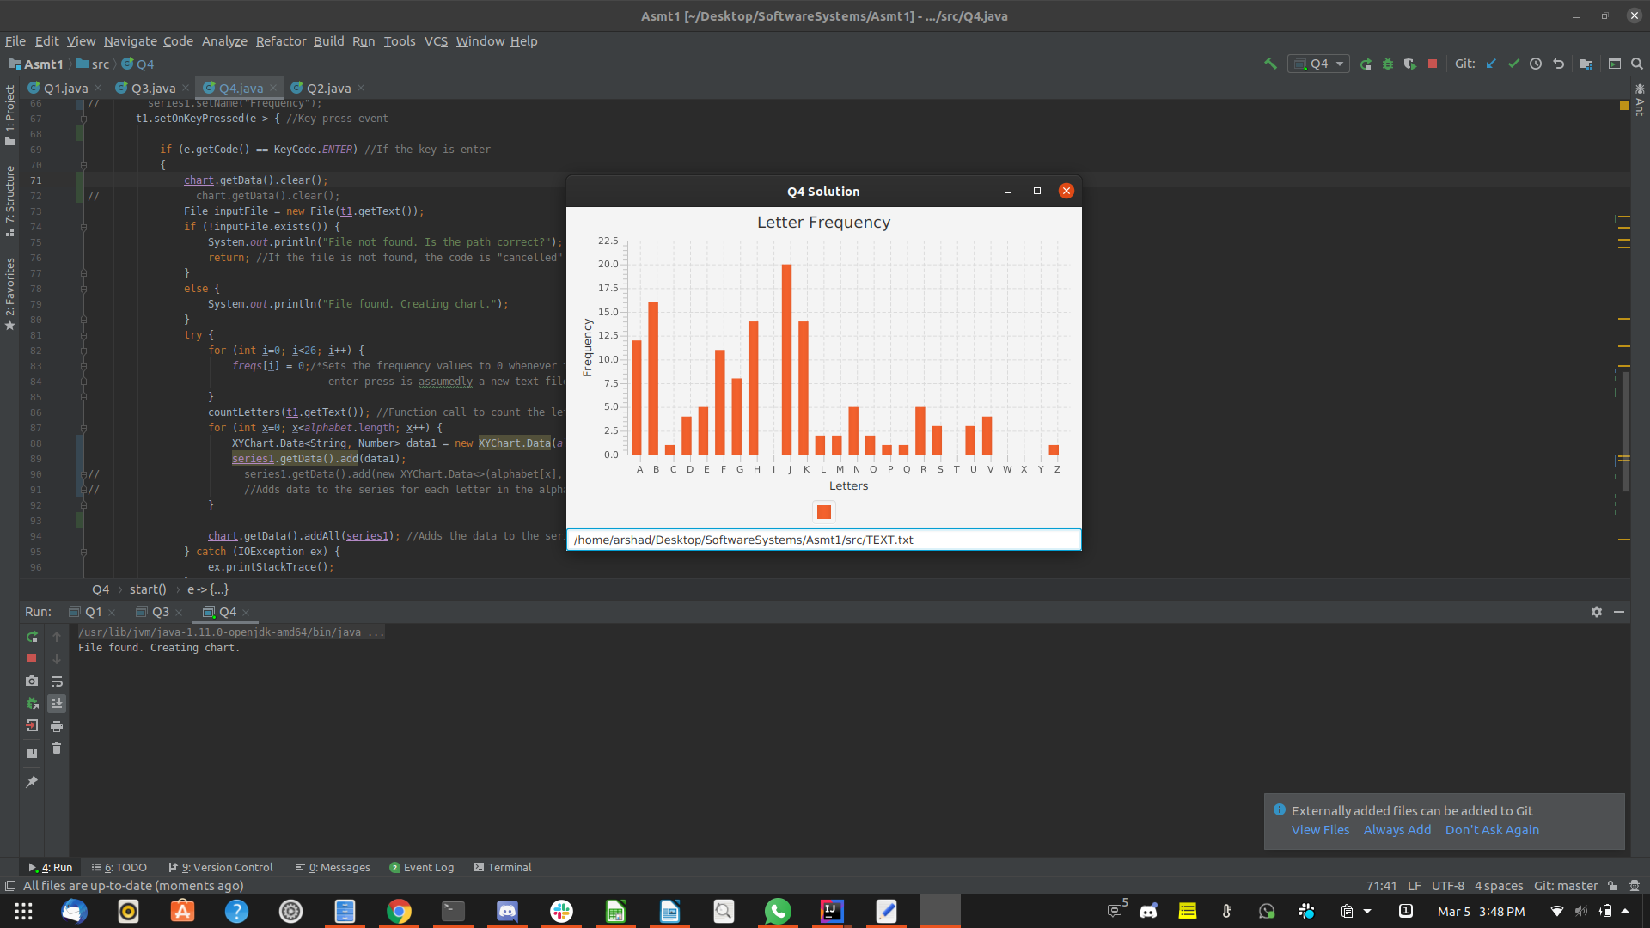
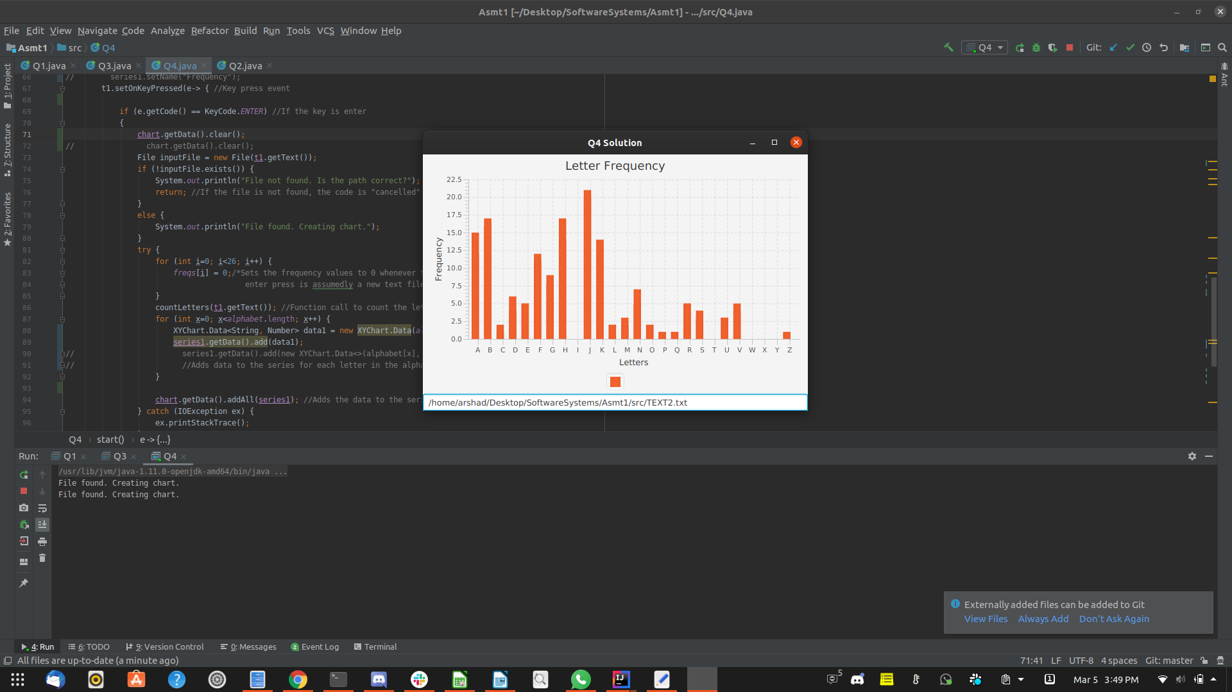

Remember:

You need to complete this file and submit it in related drop box on Blackboard, in addition to uploading your codes in your git repository, before deadline.

